`

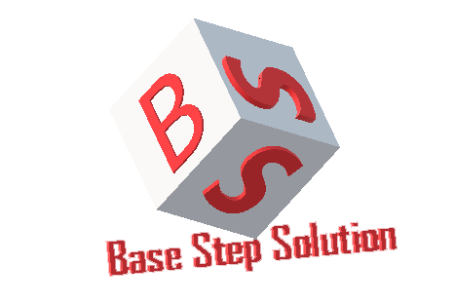

Meeting Minutes

Van Lang Admissions

# Revision Table

|  |  |  |  |
| --- | --- | --- | --- |
| Author | Date | Reason for changes | Version |
| Khoi Nguyen | 09/12/2016 | Initial Document | 1.0 |

Table of Contents

Revision Table 1

I. Purpose 3

II. Participant in meeting 3

III. Content of meeting 3

IV. To do task 4

|  |  |  |  |  |  |
| --- | --- | --- | --- | --- | --- |
| **Writer:** | Khởi Nguyễn | **Location:** | Room 701C | | |
| **Date:** | 09/12/2016 | **Start:** | 15h30 | **Finish:** | 16h30 |

# Purpose

* Review Usecase Descriptions

# participant in meeting

Customer : Lecturer Nguyễn Thế Quang

Team Capston:

* Nguyễn Thái Hiền
* Nguyễn Hoàng Anh Tài
* Đoàn Anh Minh
* Trần Xuân Hải
* Nguyễn Anh Khởi
* Nguyễn Xuân Thái Hiền

# Content of meeting

- Discuss about “Manage Homepage”

- Manage Resource : Public & Private

- Missing entity : human , internal system , external system

- Admissions system :

+ Web ( front-end )

+ Tool ( back-end )

- Admin content : approve news , manage contents…

- System admin : Create account , send mail , authorization…

- Missing function “Write news”

- Education staff only insert , not post

- Response about 500 user access into system in 2 seconds , > 500 user response about 4-5s

- Quality Attribute :

+ High : Availability , Performance , Scalability.

+ Medium : Usability , Portability , Modifiability.

+ Low : Security.

# To do task

* Update Usecase
* Update SRS

---- *** ----